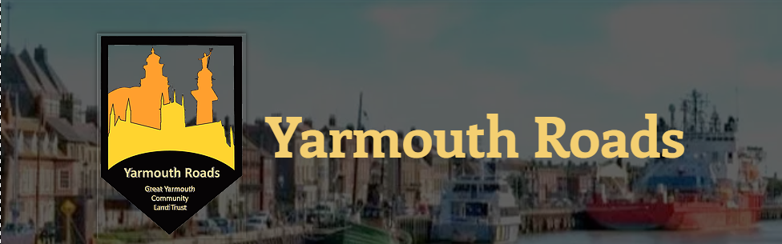

EXPRESSION OF INTEREST FOR AFFORDABLE HOUSING

|  |  |  |  |  |  |  |  |  |  |  |  |  |  |  |  |  |  |  |  |  |  |
| --- | --- | --- | --- | --- | --- | --- | --- | --- | --- | --- | --- | --- | --- | --- | --- | --- | --- | --- | --- | --- | --- |
| **Full name:** | |  | | | | | | | | | | | | | | | | | | | |
| **Address:** | |  | | | | | | | | | | | | | | | | | | | |
| **Email address:** | |  | | | | | | | | | | | | | | | | | | | |
| **Telephone number:** | |  | | | | | | | | | | | | | | | | | | | |
| **How many people in your household?** | | | | | |  | | | Adults | | | | |  | | | | Children | | | |
| **Household income:** | |  | £0 - £10,000 | | | | | |  | | £10,001 - £20,000 | | | | | | | | | | |
|  | £20,001 - £30,000 | | |  | £30,001 - £40,000 | | | | | | | |  | | £40,001 + | | | | | | |
| **What tenure of housing do you need?** | | | | | | |  | Affordable rent | | | | |  | | Shared ownership | | | | | | |
| **Do you own your own home?** | | | | | | |  | Yes | | | | |  | | No | | | | | | |
| **Are you on the District Council housing register?** | | | | | | | | | |  | | Yes | | | |  | | | No | | |
| **Please outline your local connection to \*\*** (eg. how long have you lived here, family, schooling, employment): | | | | | | | | | | | | | | | | | | | | | |
| **Is there anything else you would like us to know?** | | | | | | | | | | | | | | | | | | | | | |
| **Would you like to be added to our mailing list to be kept up-to-date?** | | | | | | | | | | | | | | |  | | Yes | | |  | No |

If you would like to express your interest in an affordable property in ** please fill in the details below to be kept on our database of interested households. Note that this does not constitute a formal application. If you are eligible you will be contacted to fill in a formal application should a property become available. To be eligible for housing you must have a local connection to the Parish and be unable to afford market rent or sale of the property that you need.

Please return completed forms to [email] or [postal address]